que 2: To read the MRI Dicom slices 1
Que 3 : To sort MRI slices using slice_location 3
Que 4: Selecting one slice to show ROI 4
Que 6: using colormap jet or colormap hot to show the color contrast of damaged 7
Que 7: To show Contour View 8
Que 8 & 9: Generating 3-D of brain slices and publish 10
Function -mri_transform 13
Function-dilation 14
Function- mri_segment 14
Function- mri_sigmoid 15
clc
clear all
close all
% Reading one dicom file
fname=['00000' num2str(1) '.dcm'];
info=dicominfo(fname);

que 2: To read the MRI Dicom slices
% Storing the dicom slices in Variable 'fname' after concatenating '0000%'
% with ',dcm'
for i=1:52
if i<=9
fname=['00000' num2str(i) '.dcm'];
else
fname=['0000' num2str(i) '.dcm'];
end
% Transformation using ITF by calling user-defined func mri_transform
trans = mri_transform(uint16(dicomread(fname)));
% Storing the transformed images in mri(:,:,i)
mri(:,:,i) = trans;
unsort_img(i,:) = [fname];
% dicominfo to obtain slice location
info = dicominfo(fname);
% getting voxel size to plot 3-D-using sliceThickness and pixel spacing
voxel_size=[info. PixelSpacing ;info. SliceThickness]';
sliceloc(i) = info. SliceLocation;
end
whos mri
figure(1)
% creating montage view for the unsorted transformed slices
montage(reshape(double(mri), [size(mri,1) size(mri,2) 1 size(mri,3)]));
set(gca,'clim',[0 350]);
title('Montage view of unsorted slices')
colormap(gray(256))
Name Size Bytes Class Attributes
mri 256x256x52 13631488 single
Warning: Image is too big to fit on screen; displaying at 25%
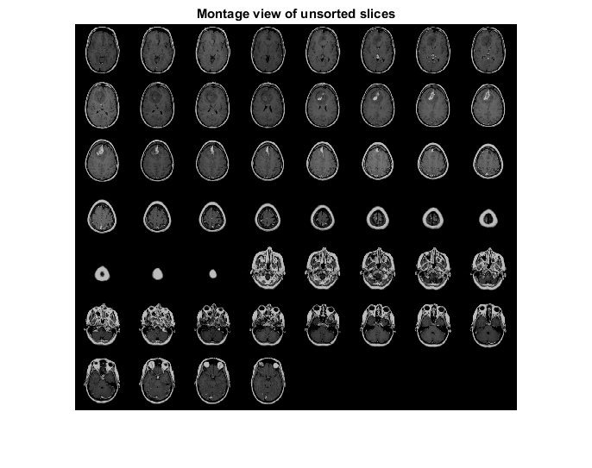

Que 3 : To sort MRI slices using slice_location
% sort the slices based on their slice locations
% Storing the sorted locations in a variable 'sorted_slice_loc'
% Iterating the loop till the sorted location is equal to unsorted loc
% Transforming the sorted slices using ITF and storing it in variable sorted_mri
sorted_slice_loc = sort(sliceloc);
for i = 1:length(sorted_slice_loc)
for j = 1:length(sliceloc)
if sorted_slice_loc(i) == sliceloc(j)
sorted_mri(:,:,i) = mri_transform(uint16(dicomread(unsort_img(j,:))));
end
end
end
% creating montage view for sorted transformed slices
figure(2)
montage(reshape(double(sorted_mri), [size(sorted_mri,1) size(sorted_mri,2) 1 size(sorted_mri,3)]));
colormap(gray(256))
set(gca,'clim',[0 256]);
title('Montage view of sorted slices')
colormap(gray(256))
Warning: Image is too big to fit on screen; displaying at 25%
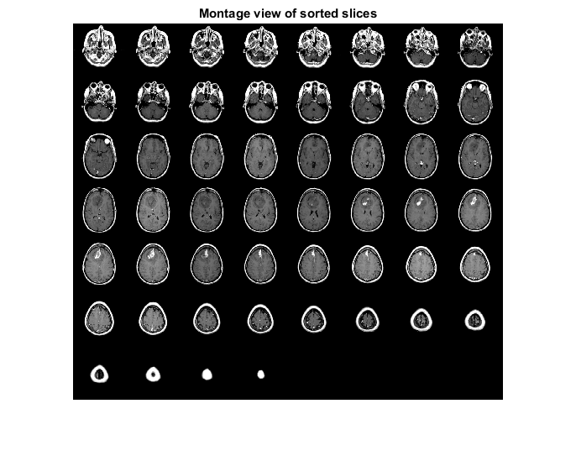

Que 4: Selecting one slice to show ROI
% Selecting 17th slice from unsorted slice list to show ROI
figure(3)
selected_slice = mri(:,:,17);
subplot(2,2,1)
image(selected_slice)
title('mri(:,:,17)')
% Que 5: 1.Segmenting the damaged tissue by calling user-defined func mri_segment by
% -selecting appropriate seed
% 2.Selecting seed 87,108 to show ROI from selected_slice
% 3.performing dilation on the damaged segmented tissue to make the area
% -uniform by calling user defined func mri_dilation
tumor_reg = mri_segment(87,108,selected_slice);
dilated_tumor_img=dilation(tumor_reg);
subplot(2,2,2)
image(dilated_tumor_img)
title('Segmented damaged tissue')
% 1.Segmenting the normal tissue by calling user-defined func mri_segment to
% -remove skull and CSF by selecting appropriate seed.
% 2.Selecting seed 114,111 to show normal tissue from selected_slice
% 3.Adding the segmented damaged tissue and normal tissue to get the
% -segmented area deprived of skull.
brain_reg = mri_segment(114,111,selected_slice);
subplot(2,2,3)
image(brain_reg)
title('Segmented healthy tissue')
segmented_img = brain_reg+dilated_tumor_img;
subplot(2,2,4)
colormap(gray(256))
image(segmented_img)
title('Segmented normal & diseased region')
% Transforming the segmented image by calling user defined func mri_sigmoid
% -& plotting histograms
figure(4)
sigmoid_trans_image=mri_sigmoid(segmented_img);
colormap jet
figure(5)
b=imshow(segmented_img);
title('Adjusting contrast of the image')
colormap jet
imcontrast(b)
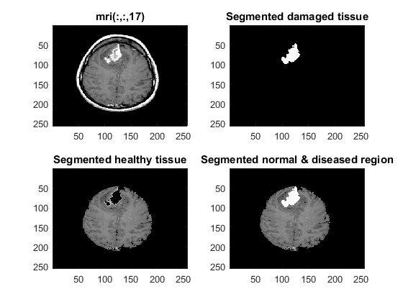
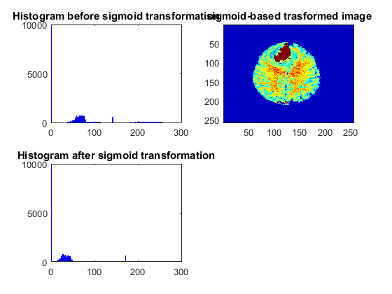
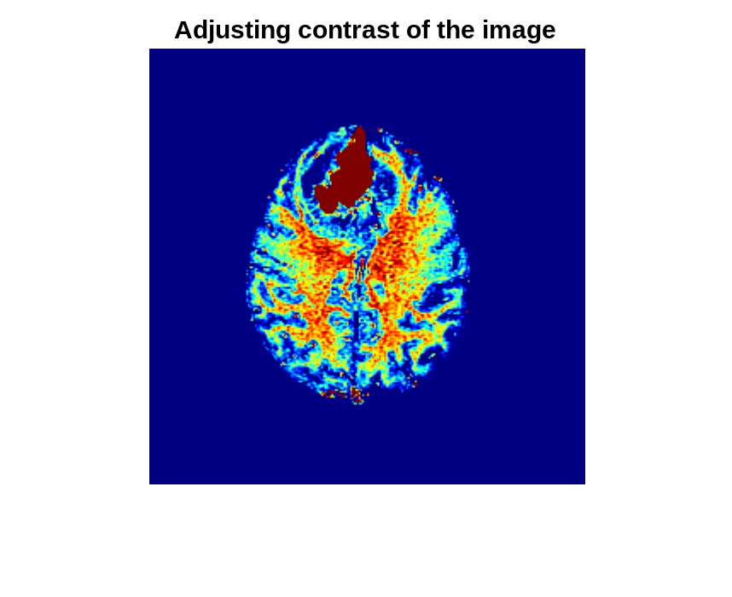
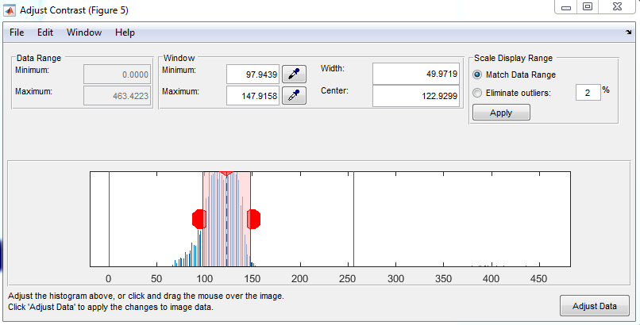

Que 6: using colormap jet or colormap hot to show the color contrast of damaged
and healthy tissue.
colormap jet

Que 7: To show Contour View
% For generating 3-D contour, taking slices from 30 to 34 in which we can
% - see injury clearly
% Segmenting the ROI from skull for all the selected slices
% Generating the 3-D contour view by using contourslice
% to plot 2-D contour using contourf
% image should be flipped from top to bottom using flipdim
figure(6)
contourf(flipdim(segmented_img,1));
title('2-D contour view')
% Selecting the Tumour based Slices
for range = 10:29;
brain_reg = mri_segment(114,111,sorted_mri(:,:,range));
segmented_img = brain_reg;
selected_set(:,:,range) = segmented_img;
end
% Seed-87,108
for range = 30:34;
tumor_reg = mri_segment(87,108,sorted_mri(:,:,range));
dilated_tumor_img=dilation(tumor_reg);
brain_reg = mri_segment(114,111,sorted_mri(:,:,range));
segmented_img = brain_reg+dilated_tumor_img;
dilated_tumor_set(:,:,range) = dilated_tumor_img;
selected_set(:,:,range) = segmented_img;
end
% Seed-55,126
for range = 34:36;
tumor_reg = mri_segment(55,126,sorted_mri(:,:,range));
dilated_tumor_img=dilation(tumor_reg);
brain_reg = mri_segment(114,111,sorted_mri(:,:,range));
segmented_img = brain_reg+dilated_tumor_img;
dilated_tumor_set(:,:,range) = dilated_tumor_img;
selected_set(:,:,range) = segmented_img;
end
% Seed-67,123
for range = 38:40;
tumor_reg = mri_segment(67,123,sorted_mri(:,:,range));
dilated_tumor_img=dilation(tumor_reg);
brain_reg = mri_segment(114,111,sorted_mri(:,:,range));
segmented_img = brain_reg+dilated_tumor_img;
dilated_tumor_set(:,:,range) = dilated_tumor_img;
selected_set(:,:,range) = segmented_img;
end
for range = 40:47;
brain_reg = mri_segment(114,111,sorted_mri(:,:,range));
segmented_img = brain_reg;
selected_set(:,:,range) = segmented_img;
end
% selecting 34th slice
image_num = 34;
cm = brighten(jet(100),1);
figure('Colormap', cm)
title('3-D contour view')
contourslice(selected_set,[],[],image_num);
axis ij tight
daspect([1,1,3])
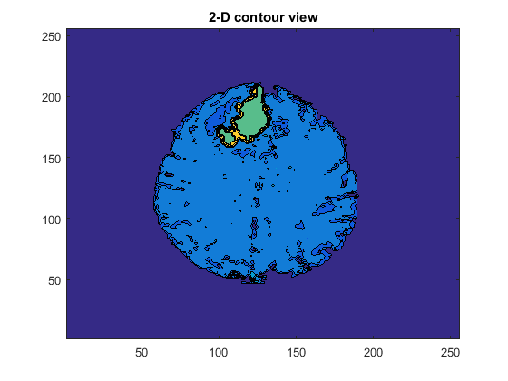
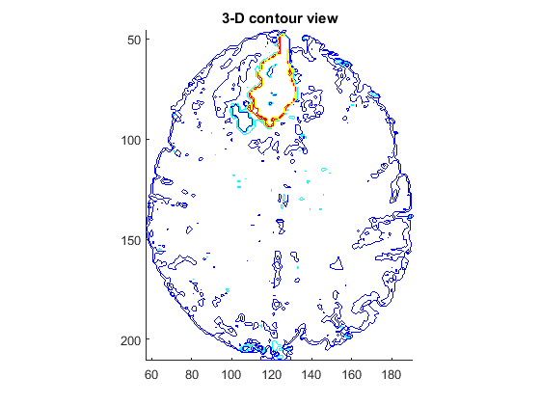

Que 8 & 9: Generating 3-D of brain slices and publish
% 1. Resizing the selected set
% 2. Flipping the dimensions 1-for top to bottom and 2 for left to right
% 3. Generating 3-D using isosurface and patch
Ds = imresize(selected_set,1,'nearest');
Ds = flipdim(Ds,1);
Ds = flipdim(Ds,2);
Ds = permute(Ds,[3 2 1]);
voxel_size2=voxel_size([1 3 2]).*[4 1 4];
white_vol = isosurface(Ds,80);
gray_vol = isosurface(Ds,200);
h=figure('visible','off','outerposition',[0 0 600 600]);
title('3-D view of selected slices')
patch(white_vol,'FaceColor','y','EdgeColor','none',...
'FaceAlpha',.3);
patch(gray_vol,'FaceColor','r','EdgeColor','none');
view(150,0);
daspect(1./voxel_size2);
axis tight;
axis off;
camlight;
camlight(-80,-10);
lighting phong;
movegui(h,'center');
set(h,'visible','on');
% generating 3-D for segmented damaged area
Ds = dilated_tumor_set;
Ds = flipdim(Ds,1);
Ds = flipdim(Ds,2);
Ds = permute(Ds,[3 2 1]);
voxel_size2=voxel_size([1 3 2]).*[4 1 4];
white_vol = isosurface(Ds,120);
gray_vol = isosurface(Ds,200);
h=figure('visible','off','outerposition',[0 0 600 600]);
title('3-D of damaged tissue')
patch(white_vol,'FaceColor','r','EdgeColor','none');
patch(gray_vol,'FaceColor','r','EdgeColor','none');
view(150,0);
daspect(1./voxel_size2);
axis tight;
axis off;
camlight;
camlight(-80,-10);
lighting phong;
movegui(h,'center');
set(h,'visible','on');
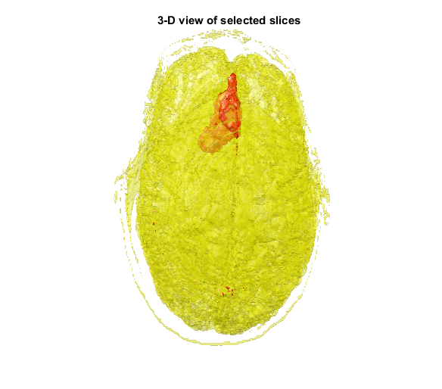
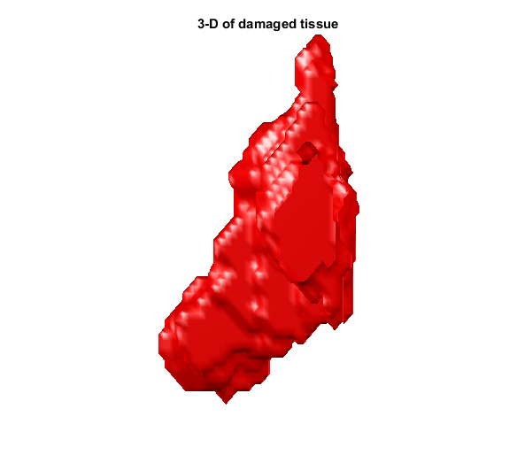

Function -mri_transform
% function transform = mri_transform(selected_slice)
% AA=single(selected_slice);
% Amin=min(AA(:));
% Amax=max(AA(:));
% CC=256*(AA-Amin)/(Amax-Amin);
%
% % This part is to perform thresholding/windowing.
%
% thre_low=20;
% thre_high=120;
%
% DD = CC < thre_high & CC > thre_low; % select/mask the region within thresholds.
% DD1=CC > thre_high;
% DD1=256.*DD1;
% DD2 = (CC-thre_low).*DD*256/(thre_high-thre_low);% multiply the thresholded mask.
% transform=DD2+DD1;

Function-dilation
% function [dilated_img]=dilation(segmented_img)
% modified_img=zeros(size(segmented_img));
% for i=2:size(segmented_img,1)-1
% for j=2:size(segmented_img,2)-1
% if (segmented_img((i-1),j) ~= 0) || (segmented_img((i+1),j) ~= 0) || (segmented_img(i,(j-1)) ~= 0) || (segmented_img(i,(j+1)) ~= 0)
% modified_img(i,j)=256;
% end
% end
% end
% dilated_img=modified_img;

Function- mri_segment
% function seedmask = mri_segment(i,j,transform)
% seedmask=zeros(size(transform));
% seedmask(i,j)=64;
% seedintensity=transform(i,j);
% seedrangemin=seedintensity-70;
% if seedrangemin < 0
% seedrangemin = 0
% end
% seedrangemax=seedintensity+70;
% % if seedrangemax > 255
% % seedrangemax = 255;
% % end
% oldseeds = 1;
% newseeds = 0;
% while newseeds ~= oldseeds;
% oldseeds = newseeds;
% newseeds = 0;
% for i = 2:size(transform,1)-1
% for j = 2:size(transform,2)-1
% if seedmask(i,j) > 0
% intens=transform((i-1),j);
% if (intens >= seedrangemin) & (intens <= seedrangemax)
% newseeds = newseeds + 1;
% seedmask((i-1),j) = transform((i-1),j);
% end
% intens=transform((i+1),j);
% if (intens >= seedrangemin) & (intens <= seedrangemax)
% newseeds = newseeds + 1;
% seedmask((i+1),j) = transform((i+1),j);
% end
% intens=transform(i,(j-1));
% if (intens >= seedrangemin) & (intens <= seedrangemax)
% newseeds = newseeds + 1;
% seedmask(i,(j-1)) = transform(i,(j-1));
% end
% intens=transform(i,(j+1));
% if (intens >= seedrangemin) & (intens <= seedrangemax)
% newseeds = newseeds + 1;
% seedmask(i,(j+1)) = transform(i,(j+1));
% end
% end
% end
% end
% end
% % seedmask for injured tissue

Function- mri_sigmoid
% function sigmoid_trans_image = mri_sigmoid(segmented_img)
% linear_trans_image=255*(segmented_img-min(segmented_img(:)))/(max(segmented_img(:))-min(segmented_img(:)));
% hist_linear_img=hist(linear_trans_image(:),256)
% subplot(2,2,1)
% bar(hist_linear_img,'b')
% ylim([0 10^4])
% title('Histogram before sigmoid transformation')
% omega=120;
% sigma=30;
% sigmoid_trans_image=255./(1+exp(-1*(linear_trans_image-omega)/sigma));
% subplot(2,2,2)
% image(sigmoid_trans_image)
% title('sigmoid-based trasformed image')
% hist_sigmoid_img=hist(sigmoid_trans_image(:),256);
% subplot(2,2,3)
% bar(hist_sigmoid_img,'b');
% ylim([0 10^4])
% title('Histogram after sigmoid transformation')
Published with MATLAB® R2015a

